Program 1

import matplotlib.pyplot as plt
x=[1,2,3]
y=[1,4,9]
plt.plot(x,y)
plt.xlabel("x axis")
plt.ylabel("y axis")
plt.title("my first graph")
plt.show()

output
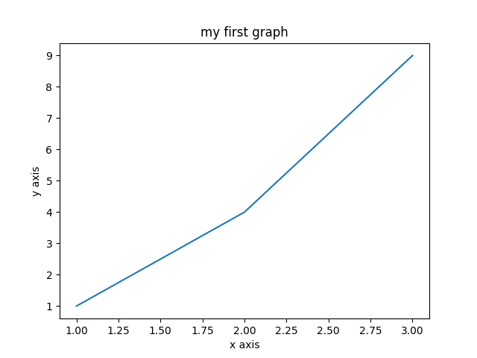

program 2

import matplotlib.pyplot as plt

#x-coordinates of left sides of bar graph
left = [1,2,3,4,5]

#height of bars
height = [10,24,36,40,5]

#label of bars
tick_label = ['one','two','three','four','five']

#plotting a bar chart
plt.bar(left, height, tick_label = tick_label,
width = 0.8, color = ['red','black'])

#naming the x-axis
plt.xlabel('x - axis')
#naming the y-axis
plt.ylabel('y - axis')
#plot tittle
plt.title('my bar chart!')

#function to show the plot
plt.show()

output

